Big O Notation

Information from: Cracking the Coding Interview, and HackerNoon- Big O for Beginners

**\*\*Not meant to be in depth but an overview of Big O**

In latence terms it is how we describe the efficiency of algorithms. There also exists **Big Omega** and **Big Theta.** But we rarely use that especially for coding interviews.

# Big O

This is used to describe the upper bound in time, AKA the worst case scenario in the efficiency of the algorithm. Common representation: **O(1)**, **O(n)**, **O(n2)**

### O(1) - Constant Time

Our algorithm will always take the same amount of time no matter how many executions of the algorithm take place. Very predictable and scalable [example](https://hackernoon.com/big-o-for-beginners-622a64760e2):

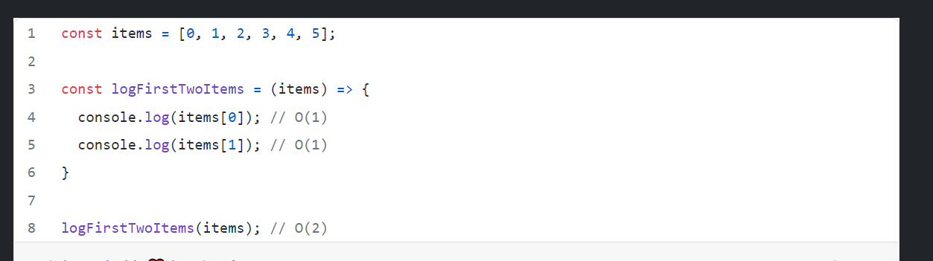

### O(n)- Linear Time

In a traditional for loop the time complexity is O(n) as it runs for every value in the for loop. The operations increase in a linear fashion according to the inputs. (n) represents the number of inputs.

### 

### 

### O(n2) - Quadratic Time

Say we have an algorithm that logs a series of pairs from an array of items. 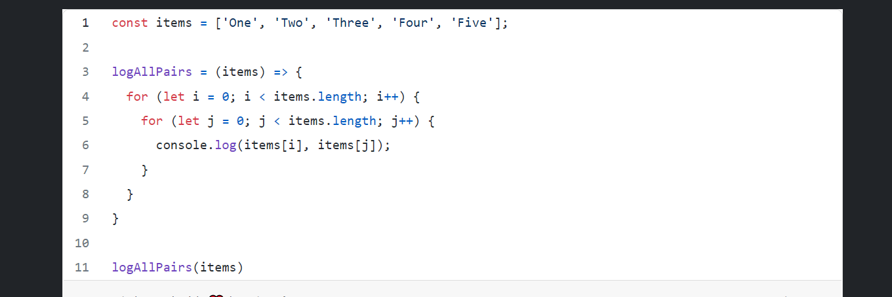

Now a good rule of thumb is if we see nested loops then we can use multiplication to get the notation. So above we have (n * n) or n2. Known as quadratic time which means for every time our input increases we increase the operations done quadratically. We DO NOT want this.

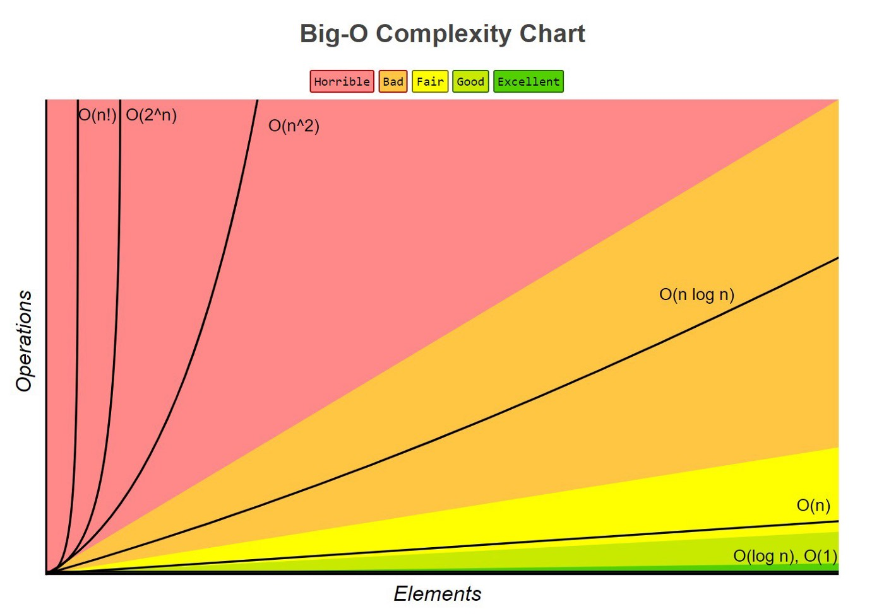

### Calculating Big O

You can go thru each line and and establish its individual runtime and put them into a simple math equation ie: O(4 + 5n + n2) so here we have a **constant + linear + quadratic.**

Now there are 4 rules that we can follow to simplify the above equation:

1. Assume the worst
2. Remove constants
3. Use different terms for inputs
4. Drop any non dominants

Let's start with rule 2/3, a constant is a number generally but lets only look at **5n**. Now we know that mathematically 5 * n does not really increase our time complexity too significantly so we can drop them as they wont ever change from **5**. And now we are left with O(4 + n + n2)

4 the more important one IMO. Now according to the above chart both **O(4)** and **O(n)** will never reach the growth curve of **O(n2),** so we can drop those terms all together. So we want to keep the most dominant term, ie: the worst case rule 1, and we are left with O(n2) which is our solution to the time complexity of the above equation.

## What about **O(log n)**?

These are simple, if you have a problem where the number of elements in the problem space are halved you’re going to have a **log n** in the runtime somewhere. A basic example is a binary search algorithm. After each search the problem search space is halved, thus decreasing the time it will take to get to the solution.

This should be a mile high view on runtimes to get you thru the simpler problems.